Task 3

Create a hello world fastapi application. Create a Dockerfile for your fastapi hello world application. Build Docker image using Docker file. Run docker image build in previous step. Push your Docker image to Docker Hub.

Create git project “dockerHelloWorld”

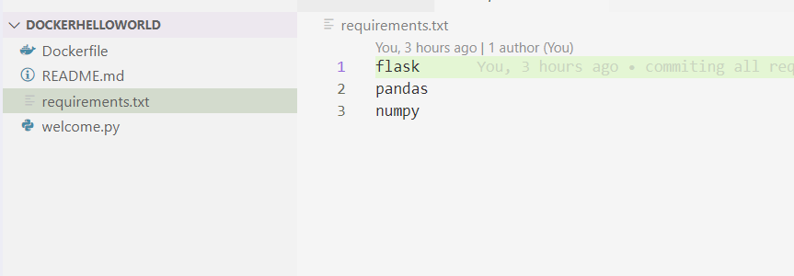

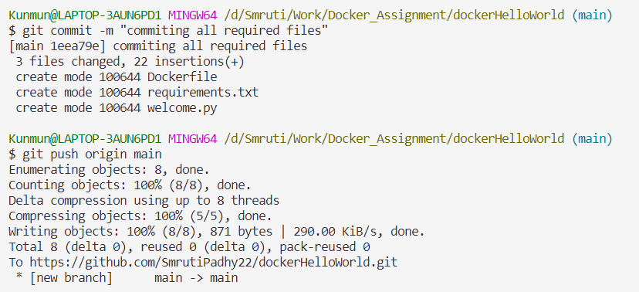

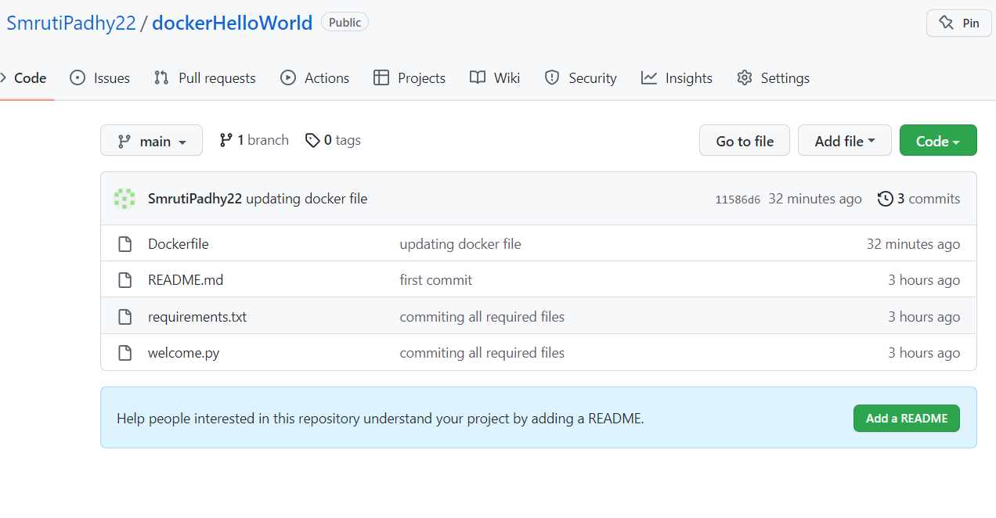

Dockerfile

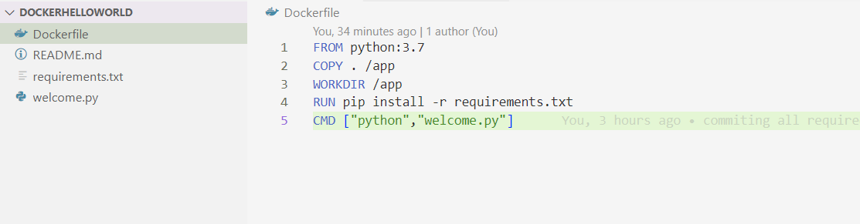

Build project

docker build -t smrutipadhy90/welcomedockerapp .

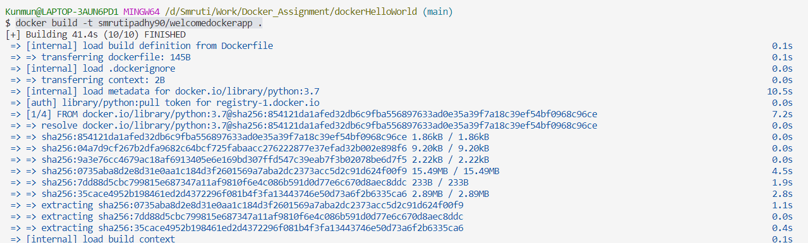

Check docker images

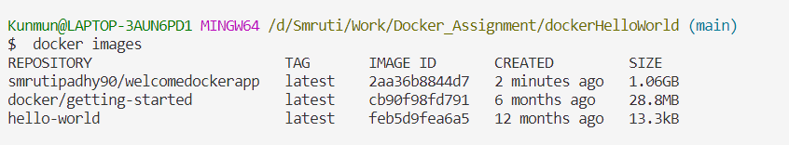

Push to docker hub

docker push smrutipadhy90/welcomedockerapp:latest

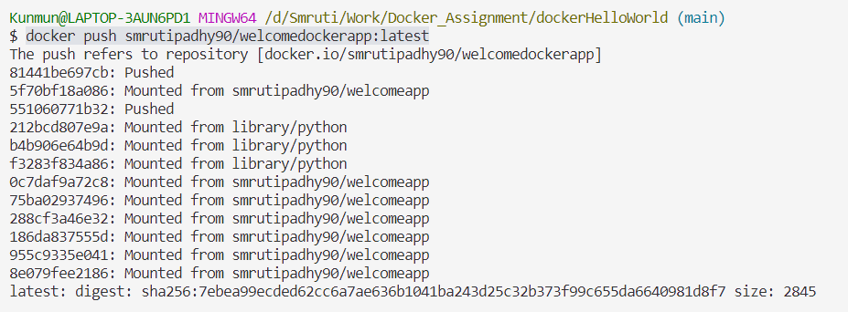

Check in Docker desktop

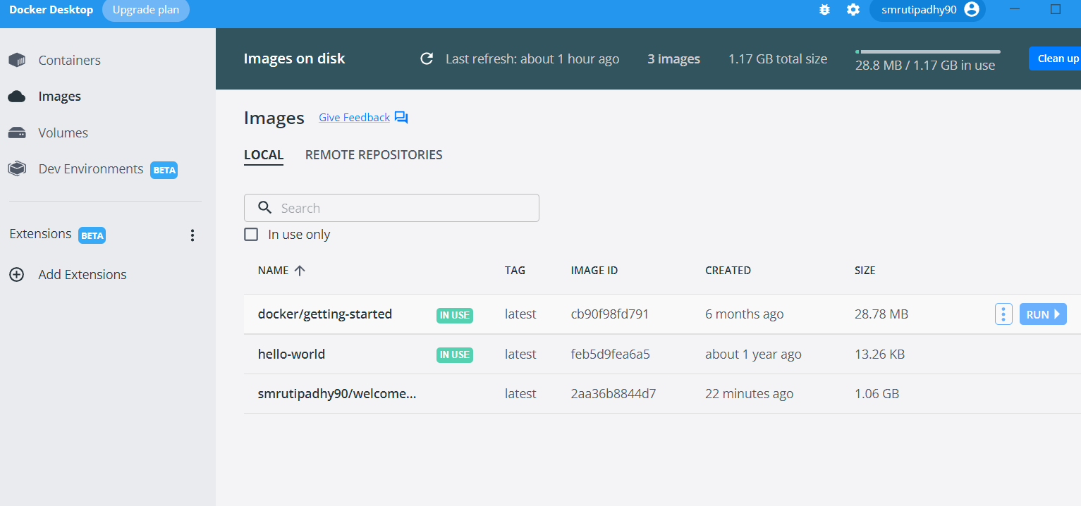

Check in Docker hub

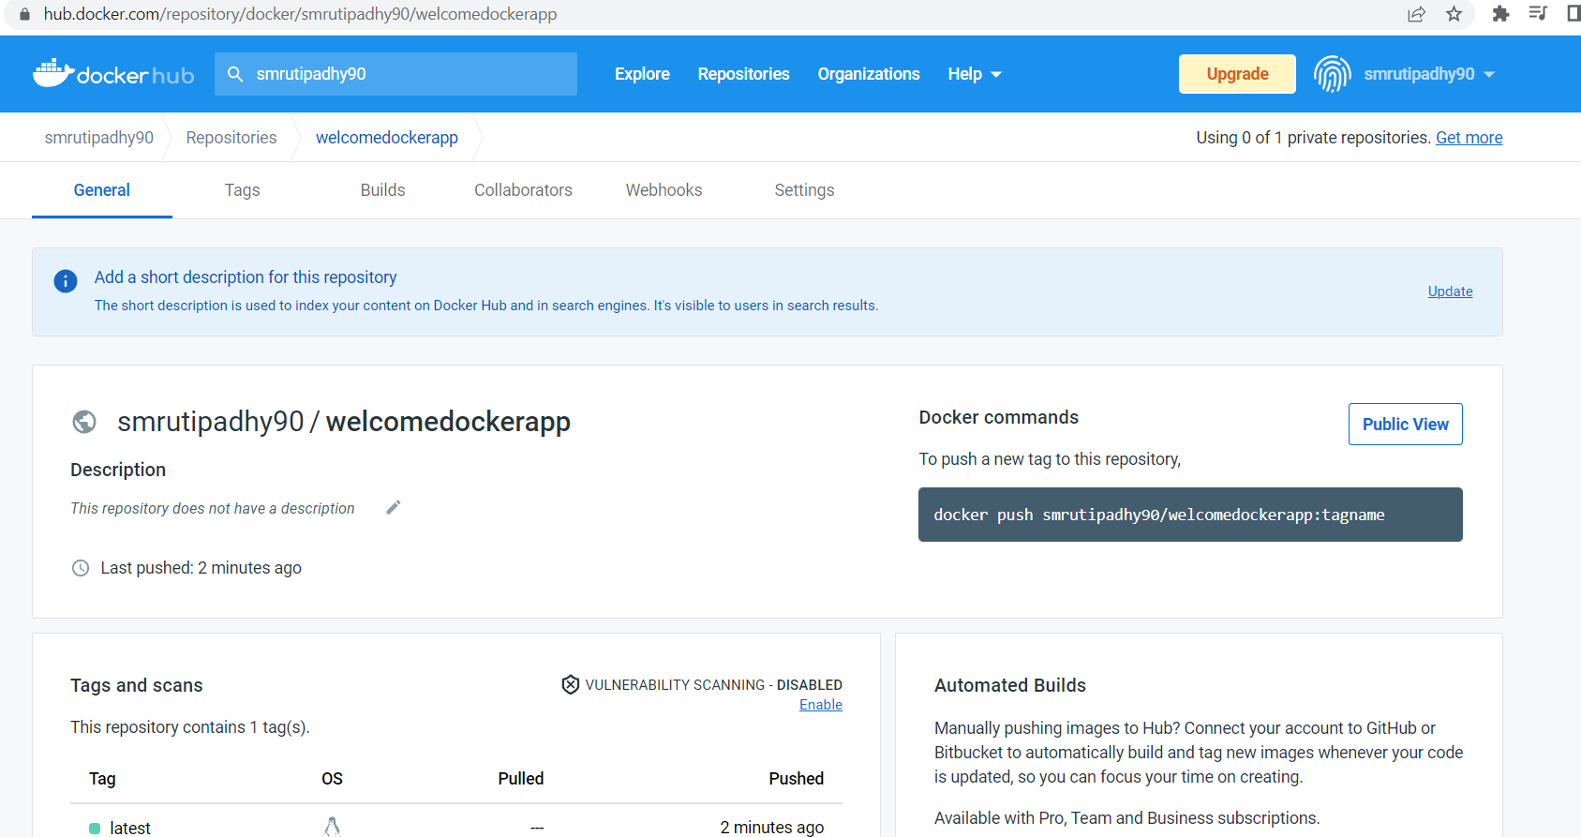

Run as localhost



